HIGH QUALITY RAW MATERIALS

High quality raw materials (HQRM) - one of the key elements GMC-simulator, which must be applied properly. HQRM influence on sales in the current period, there is no residual effect. The residual effect is possible only when the product is not implemented with HQRM and lay in stock. So it will affect on sales in future periods until it will be completely sold from warehouse.

**Scenario 12C1 - Product 2 (EU)**

Vertical - relative change in sales compared to the previous period. Horizontal - absolute value of HQRM.

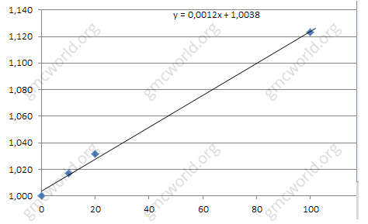

Dependence can be considered as proportionately adjusted for competitors in the group. Effect of HQRM differs for each of markets and products. Strength of the effect among markets - Nafta, EU (1.67 times wearker than Nafta), Internet (1.67 times weaker than EU).

Strength of the effect among products - product 1, product 3 (1.5 times weaker than product 1) product 2 (1.67 times weaker than product 3).

Despite strong effect on sales from the HQRM, it can be applied propely only with low SPOT price of raw materials. Because additional costs are added to the costs of production - amount of raw materials * SPOT * 0.5

Elasticities for each scenario are unique.

**Hints**

1. No residual effect
2. Dependence directly proportional with the competition in the group
3. Effect is different for each market and product

*HQRM was linked with funny bug in GMC-simulator. Calculation of stocks cost in the warehouse was provided with share of products with HQRM only in current period (example 20%) - what does it mean? Application of HQRM in production increases final cost of products. If company has not sold product in current period, it remains stored in warehouse. If HQRM will be increased (example 50%) in the next period, value of products in stock will be increased by the difference between previous and current HQRM (50% - 20% = 30%). Remember that calculation of the company's profits in the current period also consists of difference in the balances of stock between previous and current period, where increase in stock value in current period -  becomes pure profit. This is how was made brilliant in its simplicity strategy - make huge warehouse products with HQRM 0% and increase HQRM to 100% in 5 period, get from nowhere millions of additional profit, due to the rising cost stocks and leaving no chance to competitors. Nowadays bug has been fixed.*

高品质原材料

高品质原材料（HQRM）－GMC模拟器的关键要素之一，必须正确使用。HQRM对本期销售有影响，没有剩余效应。只有当产品不使用HQRM实施并存货时，剩余效果才可能。因此，将会在未来的时间内对销售产生影响，直到完全从仓库出售。

**情景12C1 - 产品2（国内）**

纵向 - 销售额相对于上一期间的相对变化。 水平 - HQRM的绝对值。



依赖性可以被认为是对组内竞争对手的成比例调整。HQRM对市场和产品各有不同。市场的影响力 - 北美，国内（比北美弱1.67倍），互联网（比国内弱1.67倍）。

产品的强度 - 产品1，产品3（比产品1弱1.5倍）产品2（比产品3弱1.67倍）。

尽管HQRM的销售产生了强劲的影响，但只能以低SPOT的原材料价格适用。 因为生产成本增加了额外成本 - 原材料数量* SPOT * 0.5

每个场景的弹性是独一无二的。

**提示**

1．没有残留效应

2．与小组内竞争依赖成正比

3．对每个市场和产品的影响效果是不同的

HQRM与GMC模拟器中的有趣的bug相关联。仓库中库存成本的计算仅在当前时期提供HQRM的产品份额（例如20％） - 这是什么意思？ HQRM在生产中的应用提高了产品的最终成本。公司本期尚未出售产品，仍存放在仓库内。如果HQRM在下一个时期增加（例如50％），股票价格将会随之前和现在的HQRM（50％ - 20％= 30％）之间的差异而增加。请记住，本期公司利润的计算也包括前期与现在本期股票价值增加成为纯利润的差额。这是如何在其简单的策略中做出了辉煌的事情 - 将HQRM的巨大仓库产品提高了0％，并在5个时期将HQRM提高到100％，由于成本上涨，并且没有机会给竞争对手带来额外的利润。现在的bug已经修复了。